Operational Concept Description (OCD)

Mission Science Information and Database System 2.0

Team 02

Nakarin Kamkheaw: Project Manager, Feasibility Analyst, Builder

Abhijeet Singh: Lifecycle Planner, Tester

Yuling Lan: Operational Concept Engineer, Requirements Engineer, Prototyper

Robert Morse: IIV&V, Shaper, System Architect

Version History
Date | Author | Version | Changes made | Rationale
10/03/12 | Yuling Lan | 1.0 | - Initial version of OCD | - Initial version of OCD for MSIDS 2.0
10/15/12 | Yuling Lan | 1.1 | - Added more content to OCD | - Finished the uncompleted part of OCD
10/22/12 | Yuling Lan | 1.2 | - Changed Figure 3 and 5  - Changed Figure 4  - Add Organizational Transformation to 3.4.1 | - The old business flow is not very clear  - There was a mistake in the element relationship diagram as some of the features are missing  - Detected some organizational which is missing from last version

Table of Contents
Operational Concept Description (OCD) i
Version History ii
Table of Contents iii
Table of Tables iv
Table of Figures v
1. Introduction 1
1.1 Purpose of the OCD 1
1.2 Status of the OCD 1
2. Shared Vision 2
2.1 Benefits Chain 3
2.2 System Capability Description 4
2.3 System Boundary and Environment 4
3. System Transformation 5
3.1 Information on Current System 5
3.2 System Objectives, Constraints and Priorities 7
3.3 Proposed New Operational Concept 9
3.4 Organizational and Operational Implications 12

Table of Tables
Table 1: The Program Model 2
Table 2: Artifacts 5
Table 3: Level of Capability Goals 8

Table of Figures
Figure 1: Benefits Chain Diagram of MSIDM 2.0 3
Figure 2: System Boundary and Environment Diagram of MSIDM 2.0 4
Figure 3: Business Workflow for MSIDM 7
Figure 4: Element Relationship Diagram for MSIDM 2.0 9
Figure 5: Business Workflow for MSIDM 2.0 11

Introduction

Purpose of the OCD
This document provides the shared visions and goals of the stakeholders of Mission Science Information and Data Management System 2.0. The key stakeholders of the project are Darin Gray, the project coordinator and system maintainer; the student staff and volunteers, as users.

Status of the OCD
The status of the OCD is currently at the version number 1.2. This document has been changed to include the agreed win-win negotiations. There has been some major change in terms of the figures, so that it is much easier to understand.

Shared Vision

Assumptions :

- Lesson plans are necessary for students who learn science.
- Data is required as proof for future funding.
- Staffs are more likely to use the system if the system is easier to use.
- Teachers want to co-operate with the mission science program.
- Elementary students want to participate in the science lessons.

Stakeholders | Initiatives | Value Propositions | Beneficiaries
- Developers  - Student Workers  - Administrator  - Other people in the department | - Measure outcome of the lesson plans  - Track Materials  - Creates Lesson Plans  - Update current lessons  - Generate reports  - Update data in real-time  - Solve change-log and Compatibility Problem  - Provide Training Manuals | - Increase funding  - Improve usability  - Stimulate the students' interest in learning science  - Reduce cost and save time  - Reduce difficulty of Planning | - Elementary School Students  - Elementary School Teachers  - Students Workers

Table 1: The Program Model

Benefits Chain
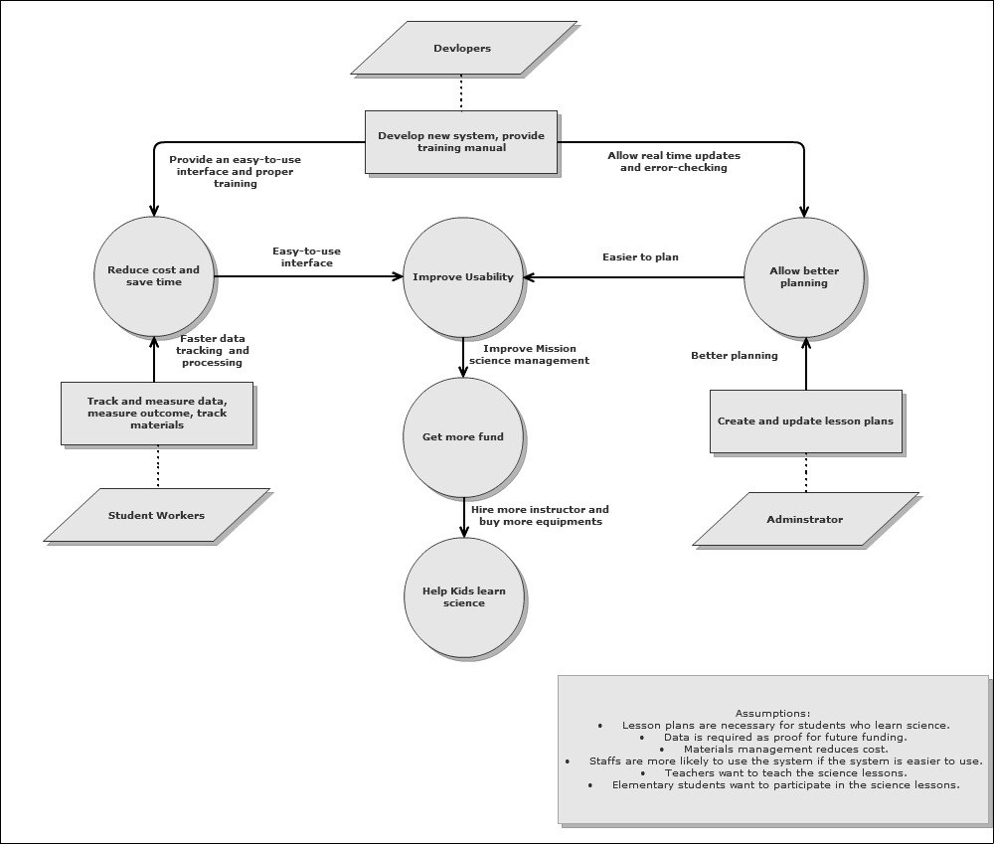

Figure 1: Benefits Chain Diagram of MSIDM 2.0

System Capability Description
- The type of system to be built:
Using existing NDI (MS Access) to implement a Information Management system of inventory, students, teachers and lessons,
- The target customer(s) for the system
Darin Gray and the student workers of Mission Science
- The need or opportunity that will be satisfied by the system
  - The proposed system will fix many problems of the existing system
  - The proposed system will do error checking for each input
  - The proposed system will be able to assign standards to lesson plans
  - The proposed system will be able to do logging of historical data
  - The proposed system will frequently make back-up

System Boundary and Environment
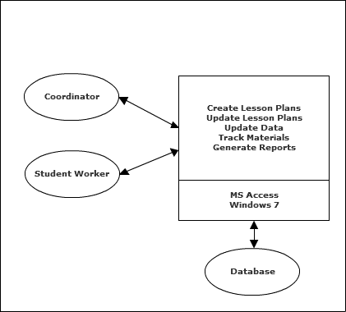
Figure 2: System Boundary and Environment Diagram of MSIDM 2.0

System Transformation

Information on Current System

Infrastructure
Microsoft Access dashboard
Access Database
Flash drive/ USB disk
PC with Windows 7 operation system

Artifacts

Artifact | Description
Books and Experiments Database | Holds a list of project books and forms for inputting or modifying existing books in the database. This database is connected to the Pre College Lesson Database.
Inventory Database | Maintains a record of all of the supplies and materials for the projects and allows for update of the inventory counts. Also holds list of materials that are checked in our out to various sites.
Mission Science Database | Contains forms for adding or modifying a student’s information.
Mission Science Sign In Input Database | Used for entering student data based on sign-in sheet by project. This database is connected to the Mission Science Database.
Pre College Lesson Database | Holds information about each project, along with the procedures, materials, lesson plans, pictures, and CA state requirements. This database is linked to the Mission Science Database, Inventory Database, and the Books and Experiments Database.

Table 2: Artifacts

Current Business Workflow

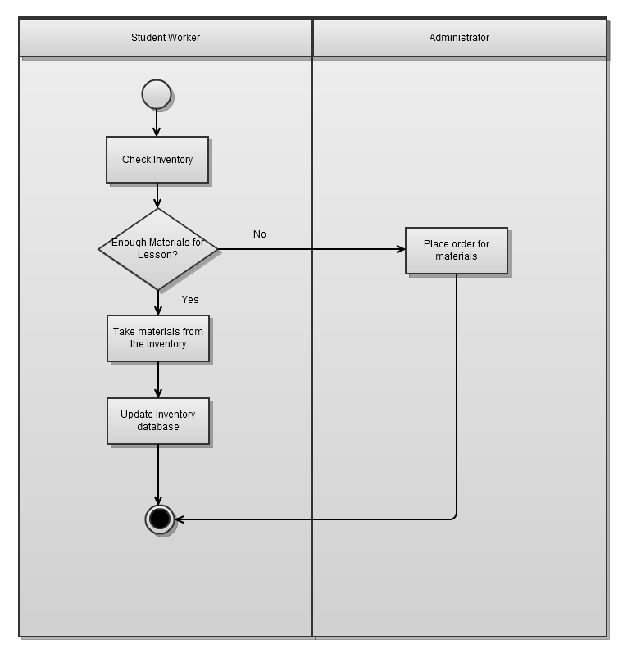
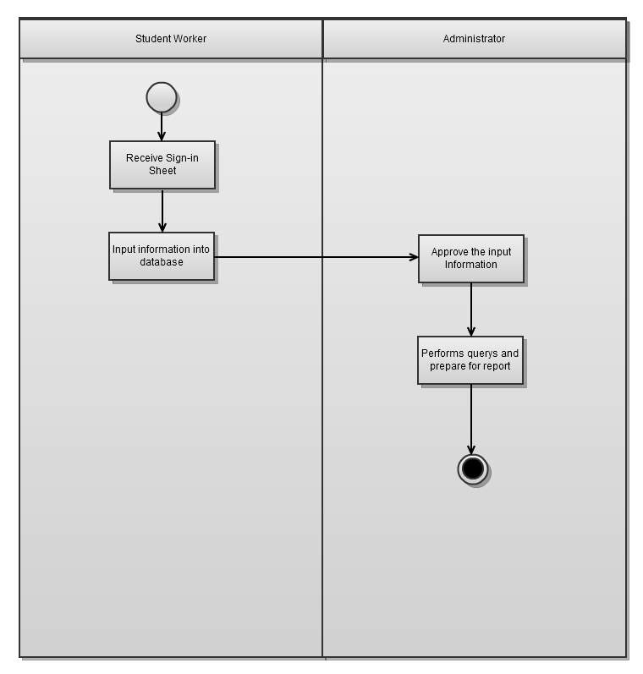
Figure 3: Business Workflow for MSIDM

System Objectives, Constraints and Priorities

Capability Goals
Capability Goals | Priority Level
OC-1 Error Checking: Student Worker should be able to detect the duplicates in the database, and make change accordingly. | Must have
OC-2 Information Editing: Student Worker should be able to make change to the existing data in the database. | Must have
OC-3 Assign Standards: Coordinator should be able to assign standards to given activities. | Must have
OC-4 Logging System: Coordinator should be able to monitor the usage of the system using a logging system. | Should have
OC- 5 Back-up Management: All databases, to include tables,  queries, and database relationships will be backed-up at  predetermined intervals. | Could have
Table 3: Level of Capability Goals

Level of Service Goals

This section is not applicable – The client did not specify any level of service requirements.

Organizational Goals
OG-1: Improve higher quality of “mission science education”
OG-2: Help education organization keep track of students’ interest in science
OG-3: Inspire more people to pursue careers in science to benefit the country.
OG-4: Increase the number of underrepresented students in science careers.

Constraints
CO-1: Windows as an Operating System: The new system must be able to run on Windows 7.
CO-2: Use MS Access 2010 as the tool: The new system should be implemented on MS Access.

Relation to Current System

Capabilities | Current System | New System
Roles and Responsibilities
User Interactions | - There is no error checking in current system | - Provide error checking functionality
Infrastructure
Stakeholder Essentials and Amenities |  | - Improve usability  - Save time using the system
Future Capabilities |  | - Logging system

Proposed New Operational Concept
This section contains information about the transformation of new operational concept that will be introduced to MSIDS 2.0.

Element Relationship Diagram
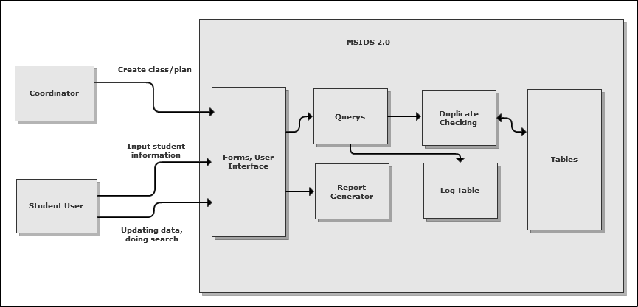Figure 4: Element Relationship Diagram for MSIDS 2.0

Business Workflows
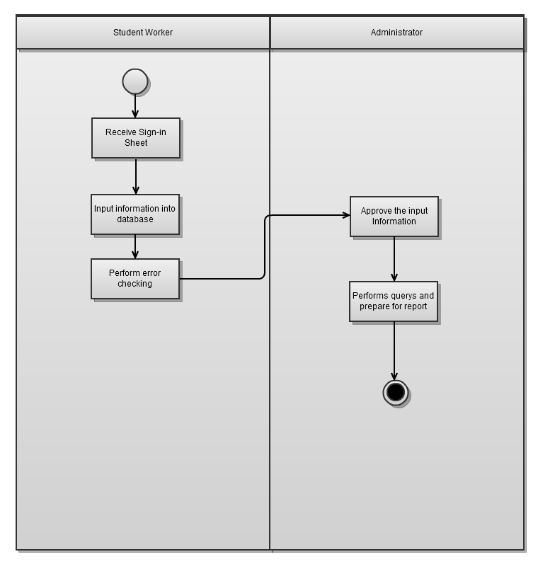

Figure 5: Business Workflow for MSIDM 2.0

Organizational and Operational Implications

Organizational Transformation
- Security system will be removed from the current system
- Log system will be added to keep track of the data changing

Operational Transformations
- Student should be able to edit data using interface
- Duplicates should be detected automatically

